Nepal College of Information Technology
Assessment Fall 2013
Program : BE (Com) Time : 3 hrs
Semester : Fall (V) FM : 100
Subject : Integrated Digital Electronics (IDE) PM : 50

- Candidates are requested to give their answer as far as practicable in their own words.
- The figure in the margin indicates the full marks
- Attempt ALL question

- a. Draw and explain the voltage transfer characteristics for the BJT inverter. (7)

b. Explain different ways to improve the speed in an ordinary RTL gate. [8]
2. a. Derive the expression for the fan-out(N) for the IC DTL NAND gate. [7]
OR
Draw an HTL NAND gate and compare HTL with DTL.

b. Calculate the fan-out for an ECL OR gate (8)

- a. Draw and explain the working of the high speed TTL circuit.(8)
OR

Draw the tri-state TTL circuit and explain its working in detail.
b. Draw the circuit diagram for the ECL OR gate and explain how it works. [7]

3. Define the following terms: Noise margins, Propagation speed, Fan-out, Power dissipation, Packing (8)
b. Consider the CMOS inverter given below. For Kn = Kp , VT (n) = VT (p) = 2V and VSS =10V, find the unique input voltage Vi(sat) defined by the simultaneous saturation of both ............transistors.(4)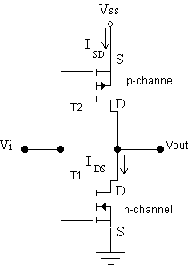
c. The rise time in NMOS is extremely long in comparison to the fall time whereas in .... case of CMOS both are almost equal. Why? (3)
- a. Draw the circuit and explain read and write operations in a six-transistor MOS dynamic cell. (7)
- What are the advantages of CCD memory over MOS memory?
Explain charge transfer mechanism in CCD memory. [8]

- a. Write the VHDL code for the behavioural description of the 4 to 1 multiplexer. [7]

b. Write the VHDL code for the structural description of the full adder. [8]

- Write short notes on.(Any two) [10]
a. IIL
b. RTL Exclusive OR gate
c. Analytic equations of MOSFETs
d. 2-input CMOS NAND gate.

